**DSA8030: Individual Industry Based Project**

**Academic Supervisor:**

Dr. Laura Boyle

Queen’s University Belfast

**Presented by :**

Anjum Banu Ismail  
MSc. Data Analytics

Student Id: 40313865

**Company Supervisor:**

Scott Morrison

Diaceutics PLC

***ML/AI for Prediction of Physician and Laboratory Diagnostic Testing***

Table of Contents

1. Abstract 1

2. Problem Statement 1

3. Data Exploration 2

4. Feature Engineering 2

4.1 Data Count 2

4.2 Dropping NA 3

4.3 Translating the year and quarter to the Date format 3

4.4 Combining Data 3

4.5 Time series Length and there Dates 4

4.1 ID Count 4

5. Data Visualization 4

5.1 Understanding ID’s with missing volumes 4

5.2 Reports and Volumes 5

5.3 Patient Volume count 6

6. Imputation for Missing Data 7

6.1 Imputation Framework 7

6.2 Noise Imputation 7

6.3 Missing Value Imputation 8

6.4 Patient Volume count after Imputation 9

7. Stationary, Lag and Decomposition of Time series 9

7.1 Detecting Stationary in Time Series 9

7.2 Data Decomposition 10

7.3 Lag and Auto-Correlation 11

8. Machine Learning Algorithms and Techniques 12

8.1 Train-Test Split and Metrics 12

8.2 ML Architecture 13

8.3 AUTO-ARIMA 14

8.4 PROPHET 14

8.5 NBEATS – Multiple and Single Model 15

8.6 RNN 16

8.7 Visualizing The Test Forecast 16

9. Web Application 18

10. References 19

10.1 Git Hub (Code) 19

10.2 Research Papers 19

10.3 Others 20

# Abstract

Using commercial data and historic Medicare data, this report aims to show my analysis of the Physicians and Laboratory patients data, and to predict the next volume of Medicare patients. The predictions are for each individual Lab and Physician ID.

# Problem Statement

Health insurance in the United States is any program that aids in paying medical expenses, whether it comes from privately purchased insurance, government-funded welfare, or social services.

|  |  |  |  |  |  |  |  |  |  |  |  |  |  |  |  |  |  |  |  |  |  |  |  |  |  |  |  |  |  |  |  |  |  |  |  |  |  |  |  |  |  |  |  |  |  |  |  |  |  |  |  |  |  |  |  |  |  |  |  |  |  |  |  |  |  |  |  |  |  |  |  |  |  |  |  |  |  |  |  |  |  |  |  |  |  |  |  |  |  |  |  |  |  |  |  |  |  |  |  |  |  |  |  |  |  |  |  |  |
| --- | --- | --- | --- | --- | --- | --- | --- | --- | --- | --- | --- | --- | --- | --- | --- | --- | --- | --- | --- | --- | --- | --- | --- | --- | --- | --- | --- | --- | --- | --- | --- | --- | --- | --- | --- | --- | --- | --- | --- | --- | --- | --- | --- | --- | --- | --- | --- | --- | --- | --- | --- | --- | --- | --- | --- | --- | --- | --- | --- | --- | --- | --- | --- | --- | --- | --- | --- | --- | --- | --- | --- | --- | --- | --- | --- | --- | --- | --- | --- | --- | --- | --- | --- | --- | --- | --- | --- | --- | --- | --- | --- | --- | --- | --- | --- | --- | --- | --- | --- | --- | --- | --- | --- | --- | --- | --- | --- | --- |
| A federally administered insurance program, Medicare is a program into which Americans contribute throughout their working lives and enrol in after retiring or if they become disabled.  Commercial insurance must protect its business interests by excluding the most likely recipients of medical care by providing coverage to people under 65.  From 2017 to 2021, we have numbers of  sufferers with malignant lung cancer that were referred by physicians (ordered testing) and laboratories (performed testing). Commercial data is always more up-to-date than Medicare data as seen in Table 1.  The purpose of the project is to create a generalized prediction model. The tasks involved in this project are as follows:   * Prepare the lab and physician data by downloading and pre-processing them. * Decide on the appropriate imputation technique and fill in the missing quarter volumes. * Training data that can predict volumes with less error is important. * Select the right model for each lab and physician ID * Create a simple web application that takes an ID as an input and predicts the right volumes for missing Medicare data | |  |  |  |  |  | | --- | --- | --- | --- | --- | | Year | Lab | | Physician | | | **Medicare** | **Commercial** | **Medicare** | **Commercial** | | 2017 | Q1 | Q1 | Q1 | Q1 | | Q2 | Q2 | Q2 | Q2 | | Q3 | Q3 | Q3 | Q3 | | Q4 | Q4 | Q4 | Q4 | | 2017 | Q1 | Q1 | Q1 | Q1 | | Q2 | Q2 | Q2 | Q2 | | Q3 | Q3 | Q3 | Q3 | | Q4 | Q4 | Q4 | Q4 | | 2018 | Q1 | Q1 | Q1 | Q1 | | Q2 | Q2 | Q2 | Q2 | | Q3 | Q3 | Q3 | Q3 | | Q4 | Q4 | Q4 | Q4 | | 2019 | Q1 | Q1 | Q1 | Q1 | | Q2 | Q2 | Q2 | Q2 | | Q3 | Q3 | Q3 | Q3 | | Q4 | Q4 | Q4 | Q4 | | 2020 | Q1 | Q1 | Q1 | Q1 | | Q2 | Q2 | Q2 | Q2 | | Q3 | Q3 | Q3 | Q3 | | Q4 | Q4 | Q4 | Q4 | | 2021 | Q1 | Q1 | Q1 | Q1 | | **Missing** | Q2 | **Missing** | Q2 | | **Missing** | Q3 | **Missing** | Q3 |   Table 1 Raw Dataset Structure |

# Data Exploration

Lab and Physician datasets have thousands of ID and each identifier has its own time series with either Medicare data or Commercial data or both.

|  |  |
| --- | --- |
| Fig 1 Quick look into the Data | **Fig 1** illustrates that the data structure is not the same for every Lab and Physician ID. Below are some of the common possibilities.   * *Medicare and commercial data can be found on some IDs* * *Some IDs may only contain Medicare information* * *ID's with only commercial data may exist* * *Volumes for some IDs will be available for all quarters from 2017 to 2021* * *Volumes for some IDs may only be available for a specific period* * *Commercial Data is current, unlike Medicare Data i.e.(2 Quarter Lag)* |

**A look at the dataset's challenges**

* Insufficient training data
* There is no interdependence among time series
* There is not a single time series that is the same
* For most IDs, quarter volumes are missing
* No Trend or Seasonality observed
* No correlation between Medicare and Commercial Volumes
* During the COVID Pandemic, there was a lot of noise in the patient's volume.

# Feature Engineering

* 1. Data Count

Once the data is downloaded for both Lab and Physician, the statistics dimensions and there feature names are established and the data is scanned to see if any of the capabilities is having NA.

|  |  |  |  |
| --- | --- | --- | --- |
| **Source** | **Rows** | **Features** | **Missing Values** |
| Lab | 18466 | ['id', 'type', 'year', 'quarter', 'volume'] | id True  type False  year False  quarter False  volume False |

|  |  |  |  |
| --- | --- | --- | --- |
| **Source** | **Rows** | **Features** | **Missing Values** |
| Physician | 18466 | ['id', 'type', 'year', 'quarter', 'volume'] | id True  type False  year False  quarter False  volume False |

Table 2 Dataset Information

As in line with the observation seen in Table 2 each of the resources has missing entries for ID Feature

* 1. Dropping NA

Since the missing values are present only in id's that's the number one key for our evaluation and prediction, and hence the missing entries may be eliminated from the datasets. The percentage of missing entries are very small with **0.10%** for Lab and **0.014%** for Physician.

* 1. Translating the year and quarter to the Date format

Within the given dataset, indices include integers. The columns 'year' and 'quarter' is combined together to create time Date format with 1st date for every Quarter and this new Date format is indexed and hence we can easily make time series evaluation.

|  |  |  |  |  |  |  |  |  |  |  |  |  |  |  |  |  |  |
| --- | --- | --- | --- | --- | --- | --- | --- | --- | --- | --- | --- | --- | --- | --- | --- | --- | --- |
| |  |  | | --- | --- | | year | quarter | | 2020 | 1 | | 2020 | 2 | | 2020 | 3 | | 2020 | 4 | |  | |  | | --- | | Date Index | | 01-01-2017 | | 01-04-2017 | | 01-07-2017 | | 01-10-2017 | |

Fig 2 Date format and Indexing

* 1. Combining Data

The given two separate laboratory and medical datasets are combined along to one Dataframe. A new column ‘source’ is created to represent the supply of the information from either Lab or Physician. Below is the final look on the Dataframe.

Features

Index

Feature to be predicted

Fig 3 Final Data Frame Snippet

* 1. Time series Length and there Dates

Any Individual time series within Lab and Physician dataset has commercial dataset with 18 quarters of databases on the contrary Medicare dataset is forever lagged with 1 or 2 Quarters of data. There Begin (Up to now) and End (Up to now) for the given dataset is mentioned in beneath table.

|  |  |  |  |
| --- | --- | --- | --- |
| **Type** | **Length** | **Start Date** | **End Date** |
| Medicare | 17 | 01-01-2017 | 01-01-2021 |
| Commercial | 18 | 01-01-2017 | 01-04-2021 |

Table 3 Time Series Length and Dates

* 1. ID Count

With ID being one of the foremost critical feature to create numerous time series required for investigation. Underneath table conveys a check on the number of unique IDs found in Lab and Physician information set which are moreover assembled from “Medicare” and “Commercial”

|  |  |  |
| --- | --- | --- |
| **Sourced** | **Type** | **Unique ID Count** |
| Lab | Medicare | 1550 |
| Lab | Commercial | 1234 |
| Physician | Medicare | 42022 |
| Physician | Commercial | 33291 |

Table 4 Unique ID count

# Data Visualization

* 1. Understanding ID’s with missing volumes

For the given Dataset the ID's are binned together depending on the volumes accessible for each quarter. The underneath plot appears us that there are exceptionally few ID's where the volumes are detailed for all the quarters for a given period.

The other set of IDs with up to 50% of information lost can be certainly be treated by applying different imputation techniques. Here the imputation will advantage us instead of overlooking them.

Fig 4 Unique ID tally based on lost volumes

We see the Amber colour is generally ruling in all 4 plots in Fig 4, appearing us that larger part of IDs has exceptionally less data. If it is imperative to examine these IDs hence we have to be request business to provide new data set.

In my examination, I have chosen the 50% as a threshold for lost values, anything over 50% lost values will basically be disregarded and not be utilized for forecast. Statistical guidance articles have stated that bias is likely in analyses with more than 50% missingness and that if more than 50% then results should only be considered as hypothesis generating.

* 1. Reports and Volumes

The first plot Fig 5(a) appears us the tally of report by Lab and Doctors, whereas the second plot Fig 5 (b) Count Plot gives a number on the overall volumes of patients.

While comparing both the plots, it is shocking to see that indeed in spite of the fact that the report from Lab are way less compare to Doctor, but the number of threatening cancer understanding tried in Lab is surpassing the patient count alluded by doctor.

|  |  |
| --- | --- |
| Fig 5 (a) Count Plot grouped by source | Fig 5 (b) Volume Plot grouped by source |

To confirm the volumes over the year, the information is grouped within source and there types and from the below plot we see that the volumes were less in year 2017 compare to other year in both Medicare and commercial Protections types. Year 2018, 2019 and 2020 have inexact same number of volumes and obviously current year 2021 being is the least because of only 2 Quarter data available till date.

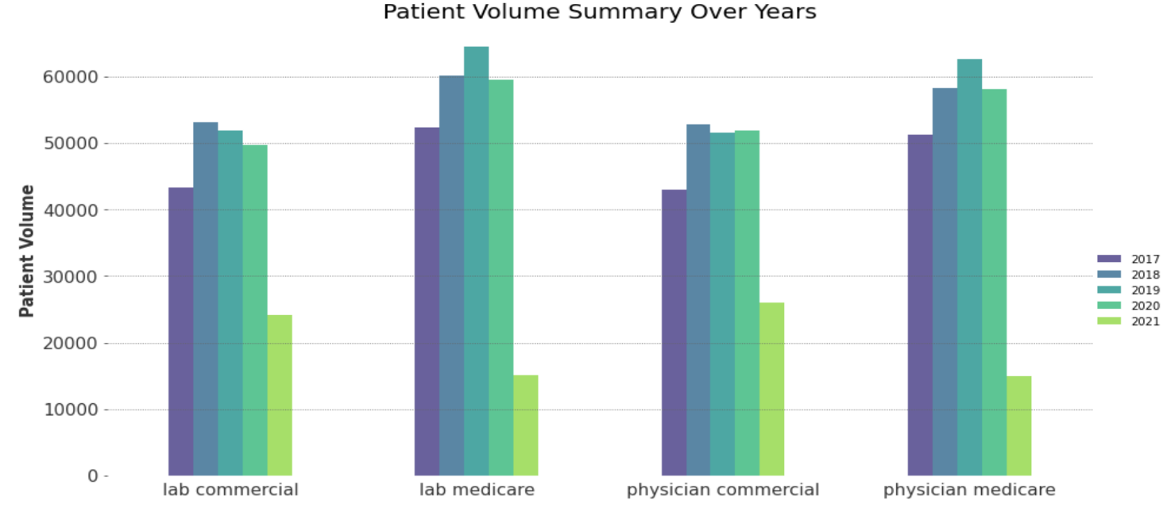

Fig 6 Patient volume over the years 2017 - 2021

From both the plots Fig 5(a)(b) and Fig 6 it is clear that that Commercial volumes were continuously less compare to Medicare

* 1. Patient Volume count

A below plot has years, usually divided into 4 quarters on the x-axis, which is the vertical axis, and volume of patient on the y-axis, which is the horizontal access.

Fig 7 Total Patient Volumes and Noise observed

Some interesting observation seen in the below plot are Medicare and Commercial patient volume are correlated to each other over the years. There is no any seasonality observed in a year. Interestingly there is a upward trend seen in Medicare volume but the same is not with Commercial volume.

The COVID-19 pandemic seems to be the most important phenomenon observed from March 2020 in virtually all countries of the world which caused a historically large and rapid declines in volumes across all categories in 2nd quarter of 2020 resulting in a noisy data.

# Imputation for Missing Data

* 1. Imputation Framework

There are 2 Imputation stages implemented in this project. At any point a given time series will have to experience at least one imputation check. Missing value Imputation is Machine learning-based procedure whereas Noise Imputation is simple mean substitution technique.

Fig 8 Flow chart representing Imputation stages

* 1. Noise Imputation

**Roll mean**

|  |  |
| --- | --- |
| This is a simple way to impute the missing data. It replaces the Noise values (2nd Quarter of 2020) by the Rolling mean with window length of 5 of the same feature.  Once the Rolling mean is calculated the value is replaced in the Volume column and time series is ready for further ML operations.  This Imputation logic is applied only for time series without any missing data or applied to time series whose missing values are already imputed. | Noise  Rolling mean of 5 previous entries  Fig 9 Noise Data Imputation with rolling mean |

* 1. Missing Value Imputation

For the time series given we assume the probability of being missing is the same for all cases and data is **Missing completely at random (MCAR)**. The missing values are imputed using combination of different strategy and [**Iterative Imputer**](https://scikit-learn.org/stable/modules/generated/sklearn.impute.IterativeImputer.html#sklearn.impute.IterativeImputer) strategy and the best resulting in low “Mean Square Error” will be used to impute missing values for the remaining time series.

Techniques used are:

1. **Simple Mean:**

Simply calculate the mean of the observed values for that variable for all individuals who are non-missing. It has the advantage of keeping the same mean and the same sample size, but many, many disadvantages.

1. **DecisionTreeRegressor**

This is a non-linear regression Imputation technique. This technique use decision trees and forests to identify horizontal segments of a data set where the records belonging to a segment have higher similarity and attribute correlations. Using the similarity and correlations, missing values are then imputed.

1. **ExtraTreesRegressor**

To Mimic the behaviour of **missForest** we have decided to choose “ExtraTreesRegressor”. This is chosen for its increased speed.

1. **KNeighborsRegressor (n_neighbors=6)**

This technique learns from samples with missing values by using a distance metric that accounts for missing values, rather than imputing them.

1. **RollMean + Fwd Fill + Back Fill**

Here a combination of 3 simple techniques is used to fill the missing value. Using roll mean with window size four takes care of the data in between, while forward and backward fill takes care of the data at extremes

|  |  |  |  |  |  |  |  |  |  |  |  |  |  |  |  |  |  |  |
| --- | --- | --- | --- | --- | --- | --- | --- | --- | --- | --- | --- | --- | --- | --- | --- | --- | --- | --- |
| 2017  Q1 | 2017  Q2 | 2017  Q3 | 2017  Q4 | 2018  Q1 | 2018  Q2 | 2018  Q3 | 2018  Q4 | 2019  Q1 | 2019  Q2 | 2019  Q3 | 2019  Q4 | 2019  Q1 | 2020  Q1 | 2020  Q2 | 2020  Q3 | 2020  Q4 | 2021  Q1 | 2021  Q2 |
| NA | 6 | 7 | 5 | 4 | NA | 10 | 4 | 5 | 8 | 6 | NA | 7 | 7 | 4 | 3 | 5 | 6 | NA |

**Back Fill**

**Roll mean (3)**

**Roll mean (3)**

**Fwd Fill**

The goal is to compare different estimators to see which one is best. This is achieved by selecting 30 different random Time Series with no missing data and adding NA’s randomly and applying these imputation techniques and validating the error between the actual and imputed values.

An overall mean square error MSE is calculate for 30 random Train and test time series and the metrics are mentioned as below. Even though the other Imputation gave less error for training data, but for the test data **RollMean + Fwd Fill + Back Fill** gave reduced error for all categories of data.

|  |  |  |  |  |  |  |  |  |
| --- | --- | --- | --- | --- | --- | --- | --- | --- |
|  | **Training** | | | | **Testing** | | | |
| Lab Commercial | Lab Medicare | Physician Commercial | Physician Medicare | Lab Commercial | Lab Medicare | Physician Commercial | Physician Medicare |
| **DecisionTreeRegressor** | 30.811193 | 4.81664 | 2.339278 | 1.89943 | 517.337584 | 103.53 | 3.764601 | 3.41823 |
| **ExtraTreesRegressor** | 22.455965 | 3.97097 | 2.063349 | 1.51593 | 509.853697 | 103.42 | 3.587014 | 3.03832 |
| **KNeighborsRegressor** | 28.390172 | 3.69579 | 1.880701 | 1.52109 | 519.169326 | 103.513 | 3.825596 | 2.81523 |
| **Simple Mean** | 33.088294 | 4.47718 | 2.366041 | 1.74221 | 510.911718 | 103.399 | 3.224616 | 2.73611 |
| **RollMean+FwdFill+BckFill** | 32.205187 | 4.23246 | 2.189622 | 1.5088 | 33.691987 | 19.9437 | 1.706198 | 1.52303 |

Table 5 Imputation techniques and there MSE

A basic plot is made beneath to show the actual and Imputed values, and it is clear that RollMean + Fwd Fill + Back Fill is practically same as actual information. Remembering the MSE error values from above table and forecast esteems from underneath plot we settle to utilize RollMean + Fwd Fill + Back Fill as our final Imputation method to fill in missing information.

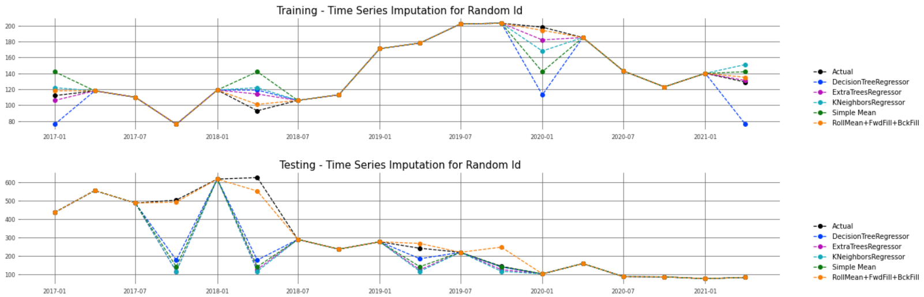

Fig 9 Actual vs Imputed values for a time series

* 1. Patient Volume count after Imputation

The drop seen in patient volume in Fig 7 during COVID pandemic stage (2020 second Quarter) should now be

similar.

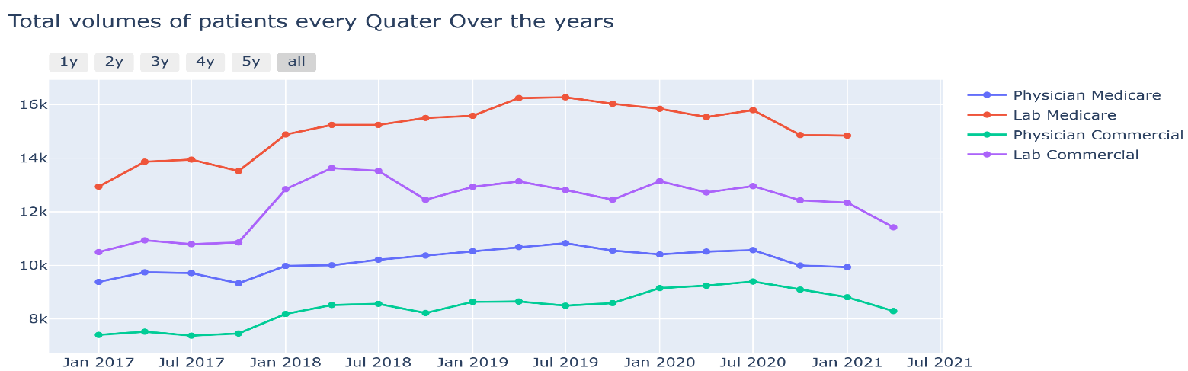

Fig 10 Total Patient Volumes without Noise

# Stationary, Lag and Decomposition of Time series

* 1. Detecting Stationary in Time Series

The most important point to make is that most of our useful time series theory applies only to stationary variables and not to non-stationary variables. Stationarity means that the statistical properties of a time series (or rather the process generating it) do not change over time. Stationarity is important because many useful analytical tools and statistical tests and models rely on it. The most basic methods for stationarity detection rely on plotting the data, or functions of it, and determining visually whether they present some known property of stationary (or non-stationary) data.

But some time it is really hard to simply visualise the plot and make a decision on time series stationary check, hence here we have used 2 different techniques to accommodate the complex data, [**Augmented Dickey-Fuller (ADF)**](https://en.wikipedia.org/wiki/Augmented_Dickey%E2%80%93Fuller_test)**(using AR of any order *p* and supporting modelling of time trends)** and [**KPSS test**](https://en.wikipedia.org/wiki/KPSS_test) **( based on linear regression, breaking up the series into three parts: a**[**deterministic**](https://www.statisticshowto.datasciencecentral.com/deterministic/)**trend, a**[**random walk**](https://www.statisticshowto.datasciencecentral.com/random-walk/)**(*rt*), and a stationary error)**

Both the test were applied for 4 categories of information and both of them came about showing series is not stationary.

|  |  |
| --- | --- |
|  |  |

Fig 11 Stationary Check

* 1. Data Decomposition

Time series decomposition involves thinking of a series as a combination of level, trend, seasonality, and noise components. Decomposition provides a useful abstract model for thinking about time series generally and for better understanding problems during time series analysis and forecasting.

|  |  |
| --- | --- |
| The components are defined as follows:   * **Level**: The average value in the series. * **Trend**: The increasing or decreasing value in the series. * **Seasonality**: The repeating short-term cycle in the series. * **Residual**: The random variation in the series. |  |

Fig 11 Time Series Decomposition

We have created a time series comprised for all 4 categories and decompose it as an additive model. In all 4 categories we see there is a upward trend. In this time series the components are available in uneven amounts hence can cause the model to predict wrong values while using ARIMA models. To improve the quality of the prediction we can perform detrending, deseasonalizing and perform some smoothing methods on it.

* 1. Lag and Auto-Correlation

Lags and Auto correlation are very useful in understanding seasonality and form the basis for autoregressive forecast models such as AR, ARMA, ARIMA, SARIMA. A simple lag operation simply shifts (offsets) a time series such that the “lagged” values are aligned with the actual time series. The **Fig 12** below illustrates the lag operation for lag 1. The lag plot shows exhibits a linear pattern for Medicare data. This shows that the data are strongly non-random and further suggests that an autoregressive model might be appropriate.

Lag plots can provide answers to the following questions:

* Are the data random?
* Is there serial correlation in the data?
* What is a suitable model for the data?
* Are there outliers in the data?

**Fig 13** is an Auto correlation plot to determine the proper lag to use with the differencing method of eliminating seasonality. The flat lines in the plot correspond to 95% and 99% confidence bands. It is obvious that the maximum corelation of about 0.75 is achieved with Lag 1 only for Physician Medicare information alone, for other categories the correlation dip under 0.70. As the lags increase the Autocorrelation is dramatically diminishing.

|  |  |
| --- | --- |
| Fig 12 Actual vs Lag 1 | Chart, line chart  Description automatically generated  Fig 13 Lags and there Correlation |

From section 7.1 we have as of now presumed that the time series are non-stationary, these can be changed or fixed by eliminating the patterns, or detrending. We have used 3 basic procedures (fig 14) 1 log difference, Rolling mean and Rolling Standard deviation. These techniques were applied, KPSS and ADF test were again conducted and the outcomes came out to show that the time series in now stationary

|  |  |
| --- | --- |
| Fig 13 Stationary Time series | Fig 14 ACF and PACF plots |

From **Fig 14** ACF and PACF plots allow you to determine the AR and MA components of an ARIMA model. Both the Seasonal and the non-Seasonal AR and MA components can be determined from the ACF and PACF plots. Looking at the plot we don’t see any significant lag or geometric decay.

# Machine Learning Algorithms and Techniques

* 1. Train-Test Split and Metrics

After all taking a subset of valid IDs which are having over half of the patient volumes and applying various Imputation techniques, at last we have an aggregate of 6031 ID’s for which ML Models ought to be applied for.

There are not many ID’s which has both Medicare and Commercials info and some are having just Medicare. The Data having both Medicare and Commercial should be predicted based on its past volumes and also past and future dependent feature Commercial volumes. whereas the time series with only Medicare data are subjected to depend on past Medicare volumes.

|  |  |  |
| --- | --- | --- |
|  | **Count** | **Prediction required?** |
| Lab ID’s Medicare + Commercial | 213 | Yes |
| Lab ID’s Medicare | 357 | Yes |
| Lab ID’s Commercial | 123 | No |
| Physician ID’s Medicare + Commercial | 2128 | Yes |
| Physician ID’s Medicare | 2215 | Yes |
| Physician ID’s Commercial | 995 | No |
| Total | 6031 |  |

Table 6 ID counts

Individual ID time series will be split chronologically based on years and Quarters, the first 70% of data will be used for Training and the rest 30% will be used for Testing and Validating the model

|  |  |
| --- | --- |
| **ID’s with both Commercial and Medicare volumes** | **ID’s with only Medicare volumes** |
| |  |  |  |  | | --- | --- | --- | --- | | **Date** | **ID** | **Medicare  volumes** | **Commercial  volumes** | | **01/01/2017** | 56227 | 97 | 4 | | **01/04/2017** | 56227 | 151 | 5 | | **01/07/2017** | 56227 | 129 | 9 | | **01/10/2017** | 56227 | 137 | 10 | | **01/01/2018** | 56227 | 144 | 47 | | **01/04/2018** | 56227 | 131 | 39 | | **01/07/2018** | 56227 | 128 | 59 | | **01/10/2018** | 56227 | 152 | 56 | | **01/01/2019** | 56227 | 127 | 61 | | **01/04/2019** | 56227 | 103 | 55 | | **01/07/2019** | 56227 | 109 | 56 | | **01/10/2019** | 56227 | 110 | 56 | | **01/01/2020** | 56227 | 87 | 43 | | **01/04/2020** | 56227 | 92 | 49 | | **01/07/2020** | 56227 | 81 | 63 | | **01/10/2020** | 56227 | 53 | 53 | | **01/01/2021** | 56227 | 61 | 53 | | **01/04/2021** | 56227 | - | 54 | | |  |  |  | | --- | --- | --- | | **Date** | **ID** | **Medicare  volumes** | | **01/01/2017** | 56209 | 4 | | **01/04/2017** | 56209 | 4 | | **01/07/2017** | 56209 | 1 | | **01/10/2017** | 56209 | 3 | | **01/01/2018** | 56209 | 11 | | **01/04/2018** | 56209 | 14 | | **01/07/2018** | 56209 | 9 | | **01/10/2018** | 56209 | 12 | | **01/01/2019** | 56209 | 12 | | **01/04/2019** | 56209 | 15 | | **01/07/2019** | 56209 | 18 | | **01/10/2019** | 56209 | 13 | | **01/01/2020** | 56209 | 9 | | **01/04/2020** | 56209 | 12 | | **01/07/2020** | 56209 | 8 | | **01/10/2020** | 56209 | 6 | | **01/01/2021** | 56209 | 7 | | **01/04/2021** | 56209 | - | |

Training

Prediction

Test / Validation

Hitting at the right machine learning algorithm is the ideal approach to achieve higher accuracy. But, it is easier said than done. Some algorithms are better suited to a particular type of Time series than others. Hence, we should apply all relevant models and check the performance. The Metric used to evaluate the best model is “MSE” (Mean Square error).

Enhancing a [model performance](https://www.analyticsvidhya.com/blog/2015/01/model-performance-metrics-classification/) can be challenging at times, especially when we have multiple time series and every time series is unique, with some having other dependent feature added as an benefit for forecast, where as others became relying upon their own historic data. To get the best accuracy for each time series forecast we have implemented some ways like “**Multiple Algorithm**” and “**Algorithm Tuning**” approaches.

* 1. ML Architecture

The entire ML process is broken down into 3 steps. The IDs are separated in stage 1 and fed to the machine learning model in their required format. In stage 2 we follow the Hyper Tuning process within every ML model and choose the best hyperparameters to train on the Training Time Series and cross-validate them with the Test Time Series, capturing the best MSE. In stage 3, each MSE generated by the five ML models for an ID is compared, and the best one is chosen to be the final model, which is saved for future forecasting of Medicare volumes.

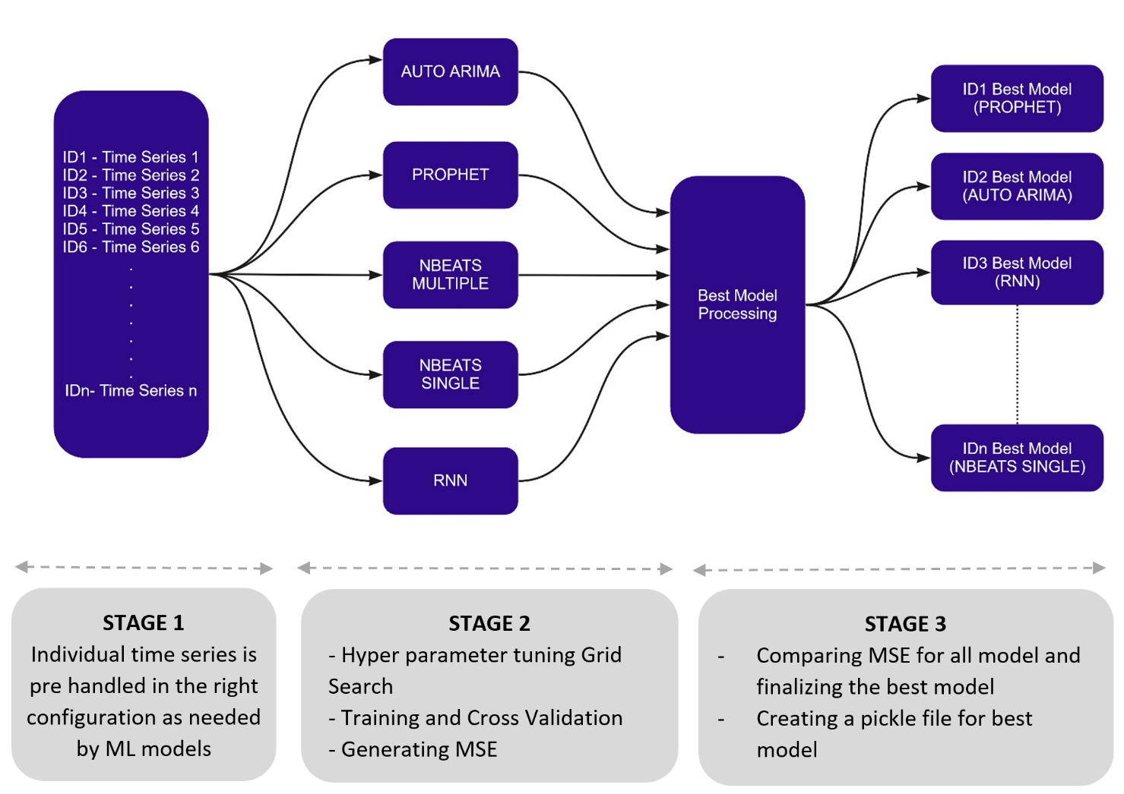

Fig 15 ML Flowchart

* 1. AUTO-ARIMA

ARIMA is an acronym that stands for Autoregressive Integrated Moving Average. Autoregression is a time series model that uses observations from previous time steps as input to the regression equation to predict the value at the next time step.  A statistical library “**Pmdarima**” is used to here.

Some of the advantages of using this library are as below:

* A collection of statistical tests of stationarity and seasonality
* Time series utilities, such as differencing and inverse differencing
* Exogenous features can be used, which in our scenario uses commercial volumes if there are any.
* Seasonal time series decompositions
* Fast Processing time

|  |  |
| --- | --- |
| Unlike ARIMA, AUTO ARIMA makes the task really simple by determining the values of Auto regression and moving average parameters. It simply bypasses the determine the values of p,q,d,P,Q. Auto ARIMA takes into account the AIC and BIC values generated to determine the best combination of parameters. | Fig 16 AUTO ARIMA Hyper tuning parameters |

AIC (Akaike Information Criterion) and BIC (Bayesian Information Criterion) values are estimators to compare models. The lower these values, the better is the model.

Auto Arima does not require any additional grid search, the optimal parameter are chosen based on the values while fitting the data. Through the "**KPSS**" method, it also identifies non-stationary time series and converts them to stationary before computing the right parameters.

* 1. PROPHET

Facebook Prophet is a procedure for forecasting time series data based on an additive model where non-linear trends are fit with yearly, weekly, and daily seasonality, plus holiday effects. It works best with time series that have strong seasonal effects and several seasons of historical data. Prophet is robust to missing data and shifts in the trend, and typically handles outliers well.

The patterns of the each time series are complicated and change dynamically over time, but Prophet follows such changes only with the trend changing. Here we are using main component like changepoint and seasonality’s to hyper tune for every time series and get the right optimal model. Below are the different values provided to get the right parameter.

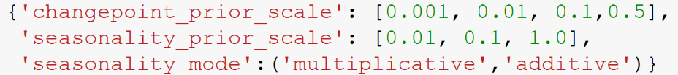

Fig 15 Prophet Hyper tuning parameters

The time series has data only for every quarter, hence the seasonality for yearly and weekly are set to False. For IDs having Commercial data there is an model created with additional regressor, The Regressor value must be known in the past and in the future, this is how it helps Prophet to adjust the forecast. **Additional regressors** feature **(Commercial Volumes)** is very important for accurate forecast calculation in Prophet. It helps to tune how the forecast is constructed and make prediction process more transparent.

* 1. NBEATS – Multiple and Single Model

**Darts** is a Python library for easy manipulation and forecasting of time series. It contains a variety of models, from classics such as ARIMA to deep neural networks. The models can all be used in the same way, using fit() and predict() functions, similar to scikit-learn. The library also makes it easy to back test models, and

|  |  |
| --- | --- |
| combine the predictions of several models and external regressors. Darts supports both univariate and multivariate time series and models. The neural networks can be trained on multiple time series, and some of the models offer probabilistic forecasts. | darts |

Some conclusions to derived are:

* Libraries like darts can provide us with a new way to work over time-series, allowing for flexibility and efficiency.
* As evident, we can load, process, and even train multiple datasets using a single library and model.
* With all the charm, one can successfully throne it as a scikit-learn for time series data.

**N-BEATS (Neural basis expansion analysis for interpretable time series forecasting)** is used for solving the univariate times series point forecasting problem using deep learning. It is a deep neural architecture based on backward and forward residual links and a very deep stack of fully-connected layers. Here the proposed architecture is augmented to provide outputs that are interpretable without considerable loss in accuracy. It uses a Past covariates models architecture as below.

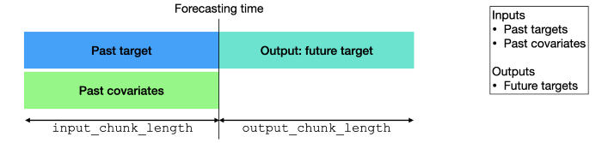

**Medicare Volumes**

**Commercial Volumes**

**Medicare Volumes**

Fig 16 Depiction of the inputs/outputs for “Past Covariates models” at prediction time

The fit() and predict() methods of these models accept only a past_covariates argument (specifying one or a sequence of Time Series). These models will look only at past values of the covariate series when making a prediction.  Grid search is used to identify the best “**input_chunk_length**”, “**output_chunk_length**” and “**n_epochs**”.

|  |  |
| --- | --- |
| The slicing of two target time series to produce some input/output training samples, in the case of a SequentialDataset (no covariate in this example).  Fig 17 The slicing of two target time series to produce some input/output training samples, in the case of a Sequential Dataset | Two Nbeats models are created, where the multiple Nbeats model is fed with individual ID data together with covariates and targets. The model is trained separately for each individual ID. Alternatively, Nbeats single takes a list of target time series and covariant time series and feeds it to the model. It is not necessary that the series used for training be the same length (in fact, they do not even have to be the same frequency) as shown in Figure 17. |

* 1. RNN

Darts library also includes RNN Model. RNNModel is fully recurrent in the sense that, at prediction time, an output is computed using these inputs:

* The previous target value, which will be set to the last known target value for the first prediction, and for all other predictions it will be set to the previous prediction
* The previous hidden state
* The current covariates (if the model was trained with covariates)

This model is suited for forecasting problems where the target series is highly dependent on covariates that are known in advance.

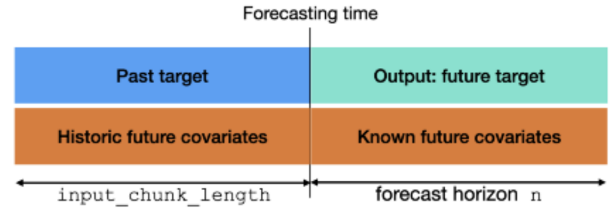

**Medicare Volumes**

**Commercial Volumes**

**Commercial Volumes**

**Medicare Volumes**

Fig 17 Depiction of the inputs/outputs for “Future Covariates models” at prediction time

The fit() and predict() methods of these models accept only a future_covariates argument (specifying one or a sequence of Time Series). These models will look only at past values of the covariate series when making a prediction.  Grid search is used to identify the best “**input_chunk_length**”, “**forecast_horizon**”, “**hidden state dimension**”, “**model (LSTM / GRU)**” and “**n_epochs**”.

* 1. Visualizing The Test Forecast

Following the training time series using multiple algorithms, the test time series is then used to predict the results. Each model's new forecast is plotted alongside its actual time series, as well as its MSE and MAPE scores. Below are the plots for the random Lab and Physician ID’s. Some ID’s are having nest MSE with AUTO ARIMA and some with other models likes Nbeats with no common trend or pattern observed.

Using MSE generated for ID below are final best models count.

|  |  |  |  |
| --- | --- | --- | --- |
| AUTO_ARIMA 🡪 1808 IDs | PROPHET 🡪 835 IDs | | RNN 🡪 698 IDs |
| NBEATS Multiple 🡪639 IDs | | NBEATS Single 🡪 933 IDs | |

# Web Application

A simple Web application is created by integrating Machine Learning into Web Applications with Flask. The final model for each ID is save as a pickle file which will be used to predict the output when new input data is provided from our web-app.

Now that we have our models, we can start developing our web application with Flask and below are the steps followed.

* + 1. Install Flask in IDE. As part of this project Sypder IDE was used to develop flask applications.
    2. Import necessary libraries, initialize the flask app, and load our ML models.
    3. Define the app route for the default page of the web-app.  @app.route("/") is a Python decorator that Flask provides to assign URLs in our app to functions easily. Whenever we hit the app domain *localhost:5000*at the given .route() it execute the home() function takes to ‘home.html’. Flask uses the Jinja template library to render templates. In our application, we will use templates to render HTML which will display in the browser.
    4. We create a new app route (‘/predict’) that reads the input from our ‘home.html’ form and on clicking the predict button, outputs the result using render_template

**Project Structure:**

The project is saved in a folder called “src”. On running the ‘app.py’, our application is hosted on the local server at port 5000.

|  |  |
| --- | --- |
| * Model/pickle/best_mse_dict.pkl — This is the pickle file with final ML model for each ID * app.py — This is the Flask application created * templates — This folder contains our ‘home.html’ and ‘predict.html’ file. This is mandatory in Flask while rendering templates. All HTML files are placed under this folder. * static — The static folder in Flask application is meant to hold the CSS and JavaScript files and images * requirement.txt — The requirements.txt file will contain all of the dependencies for the flask app. |  |

**Running Web app:**

* When **app.py** is executed

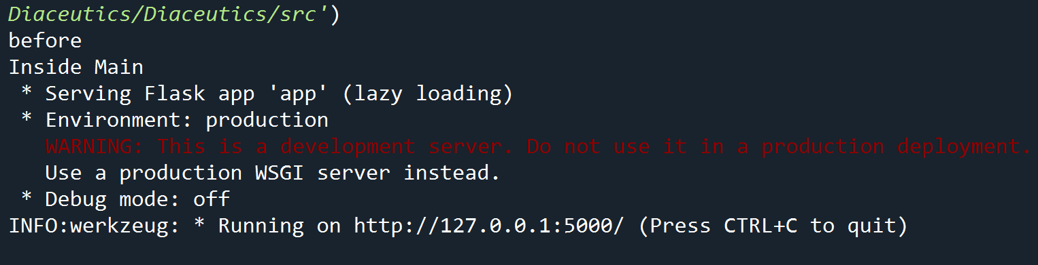

* On clicking on the provided URL we get our website:

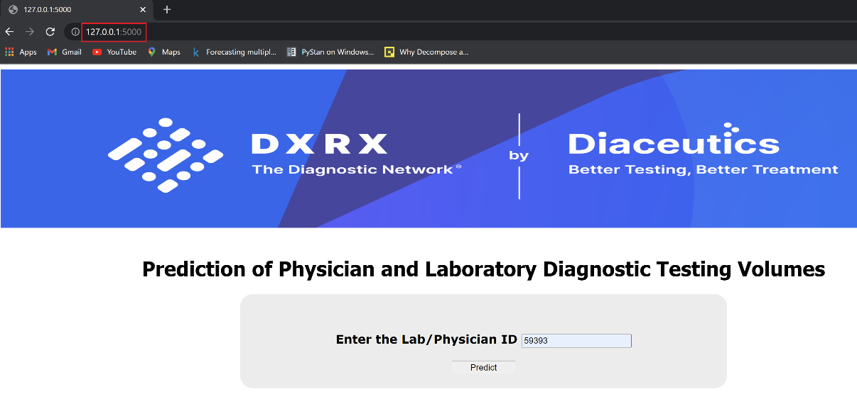

* On entering the ID and clicking on predict button we are taken to the predict page where the predict function renders the ‘predict.html’ page with the output of our application.

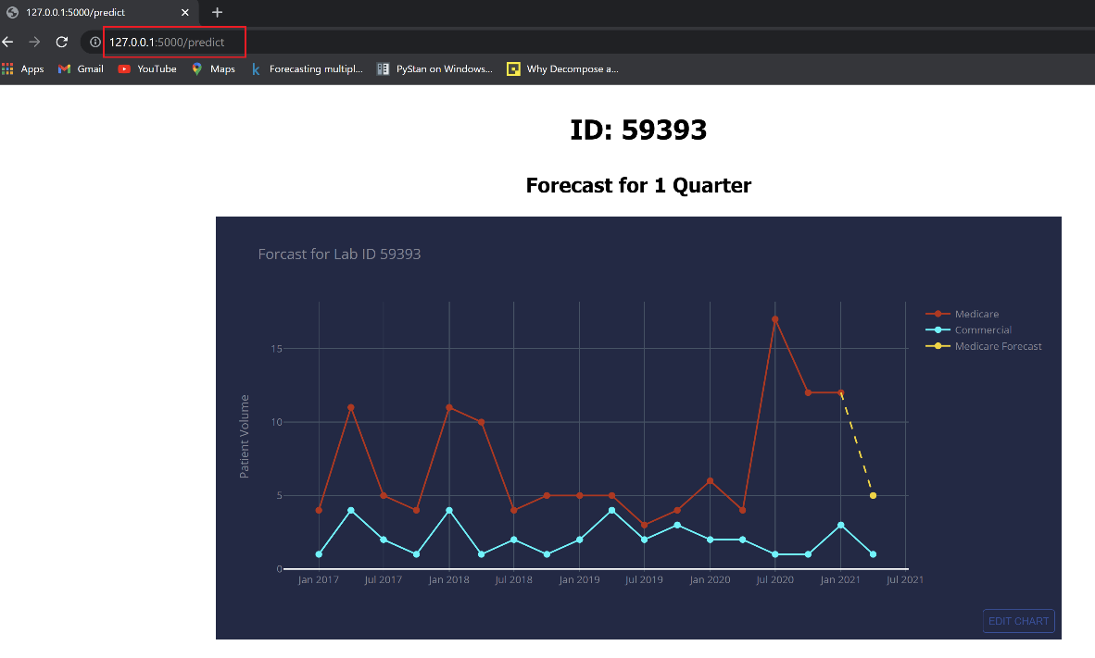

# References

* 1. Git Hub (Code)

<https://github.com/AnjuBanu/Diaceutics_Medicare_Forecast.git>

* 1. Research Papers

Application of facebook's prophet algorithm for successful sales forecasting based on real-world data (2020) University of Sarajevo, Bosnia and Herzegovina<https://arxiv.org/ftp/arxiv/papers/2005/2005.07575.pdf>

N-beats: neural basis expansion analysis for interpretable time series forecasting (2020) Element AI <https://arxiv.org/pdf/1905.10437.pdf>

Fundamentals of Recurrent Neural Network (RNN) and Long Short-Term Memory (LSTM) Network (2020) <https://arxiv.org/pdf/1808.03314v9.pdf>

Distributed and parallel time series feature extraction for industrial big data applications (2017) University of Freiburg, Freiburg, Germany <https://arxiv.org/pdf/1610.07717v3.pdf>

Deep Learning For Time Series Classification (2020) <https://arxiv.org/pdf/2010.00567v1.pdf>

* 1. Others

Forecasting: Principles and Practice” by Rob J. Hyndman and George Athanasopoulos <https://otexts.com/fpp2/arima-r.html>

“**Time Series Analysis**” by James Douglas Hamilton

Time Series Made Easy in Python [https://github.com/unit8co/darts](https://medium.com/sfu-cspmp/doppler-effect-hierarchical-time-series-forecast-for-apparel-industry-45a55bb23be6)

Darts Nbeats Documentation <https://unit8co.github.io/darts/examples/08-NBEATS-examples.html>

Pmdarima https://pypi.org/project/pmdarima/

Time Series Forecasting Methods in Python (Cheat Sheet) <https://machinelearningmastery.com/time-series-forecasting-methods-in-python-cheat-sheet/?unapproved=627419&moderation->

Prophet – Forecasting at scale by Facebook https://facebook.github.io/prophet/

Hierarchical Time Series Forecast for Apparel Industry — Doppler Effect <https://medium.com/sfu-cspmp/doppler-effect-hierarchical-time-series-forecast-for-apparel-industry-45a55bb23be6>

Flash Web application Framework https://palletsprojects.com/p/flask/

Forecasting multiple time-series using Prophet in parallel <https://medium.com/spikelab/forecasting-multiples-time-series-using-prophet-in-parallel-2515abd1a245>